**Task – 2**

Context Popularity

1. Lebron James

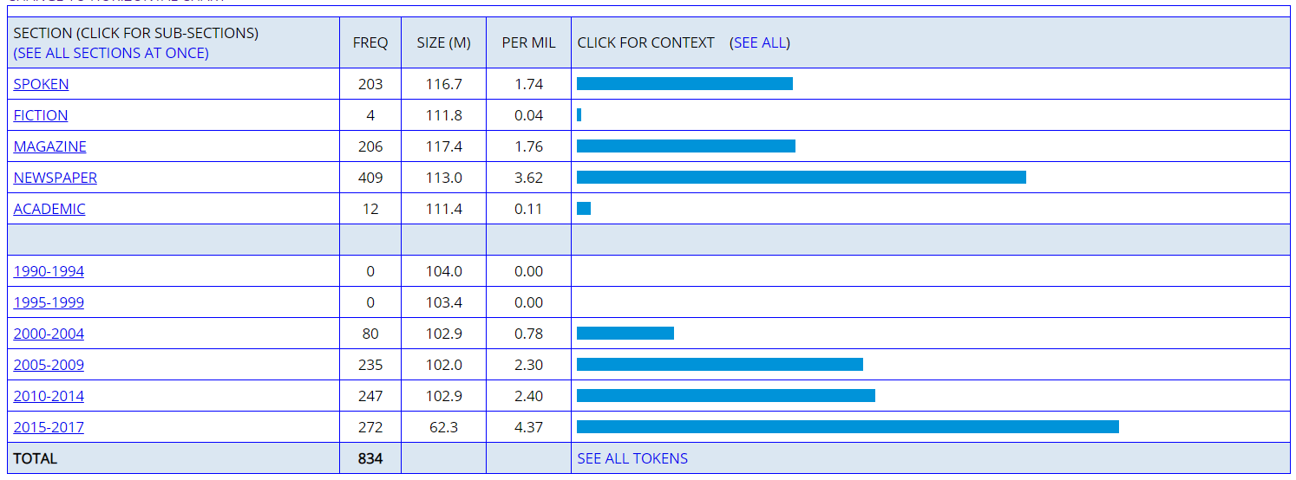

Max popularity: 2015 – 2017

During these years LeBron James was at the peak of his basketball career. He played for the Cleveland cavaliers team during this period and won the NBA championship in 2016.

1. Barak Obama

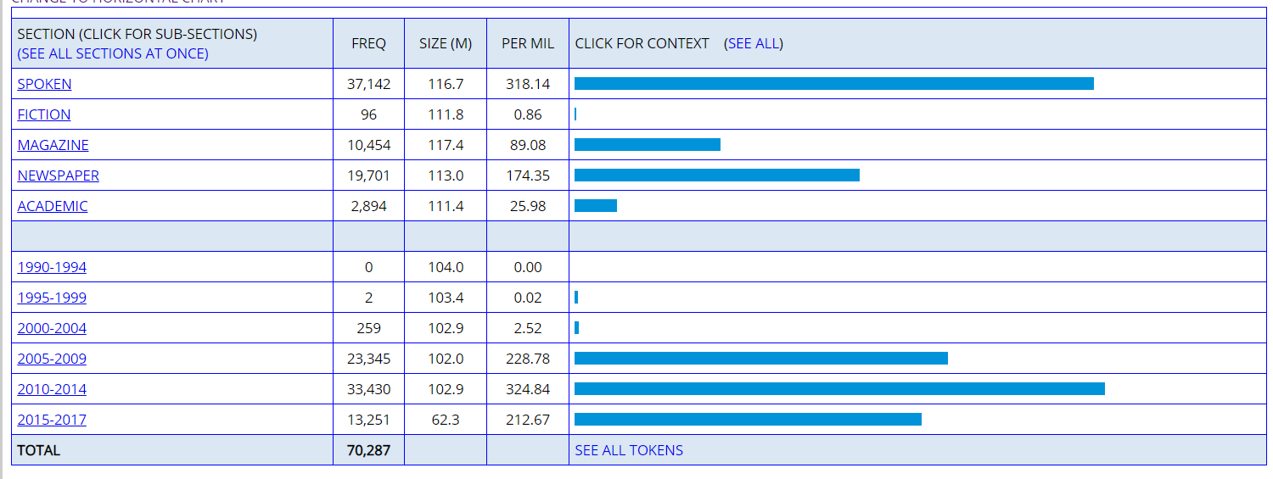

Max popularity: 2010- 2014

Barak Obama was the president of the united states of America for the duration of January 20, 2009 – January 20, 2017. Hence during his campaigning for his second term during 2013 his is has the highest popularity.

1. Earthquake

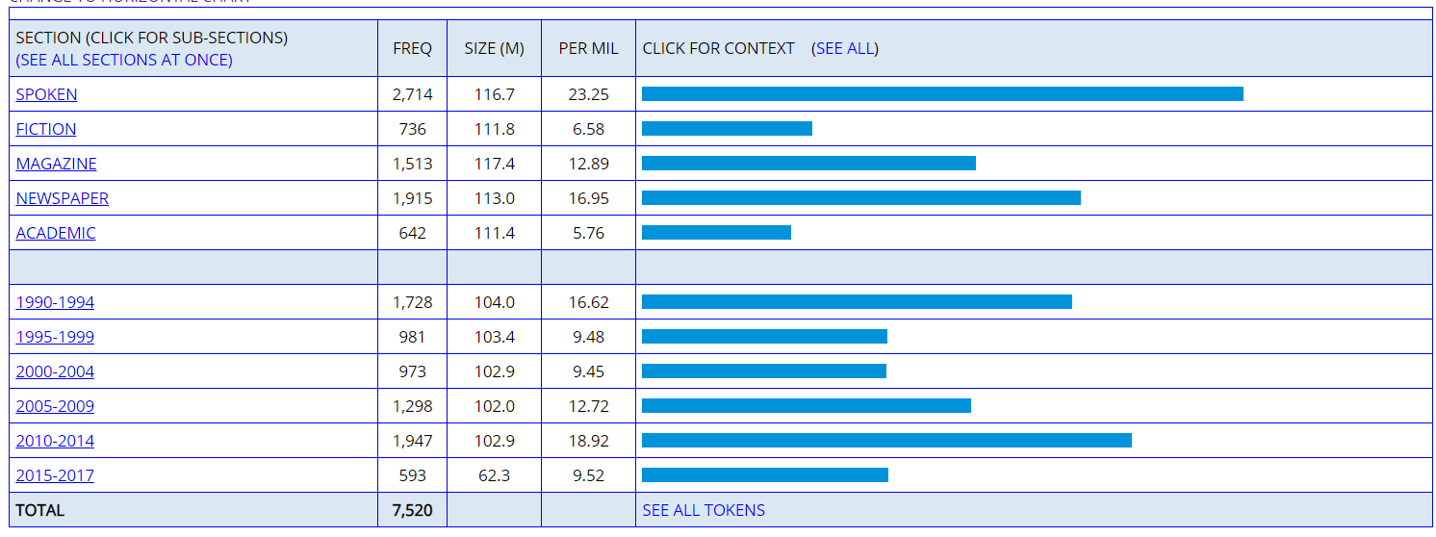

Max Popularity – 2010 – 2014

The Japan earthquake took place in 2011. It was a massive natural disaster which had claimed more than 20,000 lives. This is why the word earthquake was mentioned so many times in this period.